|  |
| --- |
| **COLOR SPACES IN COMPUTER VISION**  **SYED HARSHATH S 2023510045** |

**INTRODUCTION**

Color is a fundamental component of human visual perception, and understanding how colors are represented digitally is essential in the field of computer vision. A color space is a specific organization of colors, helping computers interpret, manipulate, and analyze color information efficiently. While the RGB color space is the most common in digital systems, it is not always optimal for tasks like compression, segmentation, or perception modeling. Thus, many alternative color spaces are used, tailored to different applications such as video processing, image editing, and printing.

**WHY OTHER COLOR SPACES:**

Other color spaces are used because they offer specific benefits for different applications:

* **Better compression:** Color spaces like YCbCr or YUV separate brightness from color, allowing for chroma subsampling which reduces file size with minimal quality loss.
* **Improved object detection:** LAB and LUV color spaces are perceptually uniform, making it easier to distinguish between different regions based on human visual perception.
* **Efficient broadcasting:** YIQ and YUV were developed for analog television systems to optimize bandwidth usage while preserving visual quality.
* **Accurate color analysis:** LAB is device-independent and designed to approximate human vision, making it useful in industries like printing and textile.

In summary, alternative color spaces are chosen when they provide a more suitable representation of image data for the task at hand, leading to improved efficiency, accuracy, and visual quality.

**1. YPbPr COLOR SPACE :**

**Definition and Usage:**

YPbPr is an analog color space derived from RGB and used in video electronics. It separates an image into three components:

* **Y' (Luma):** Represents brightness
* **Pb:** Blue difference chroma
* **Pr:** Red difference chroma

**RGB Image Conversion to YPbPr :**

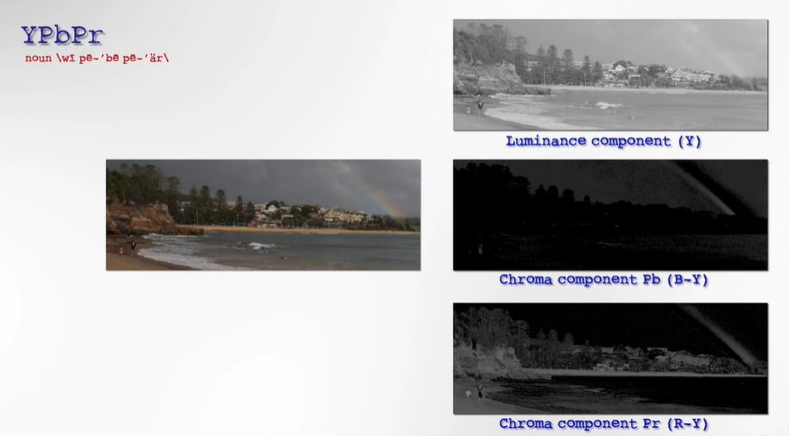

**Mathematical Relation to RGB:**

* HDTV Luma: Y' = 0.2126R + 0.7152G + 0.0722B
* SDTV Luma: Y' = 0.299R + 0.587G + 0.114B
* Pb = 0.564(B - Y')
* Pr = 0.713(R - Y')

**Analog Characteristics:**

* Carries sync information on the Y' channel
* Signals typically range from 0 to 700 mV
* No color multiplexing → less color bleeding

**Real-World Applications:**

YPbPr is used in DVD players, set-top boxes, video game consoles, and older HDTVs. It supports resolutions up to 1080p and works with standard RCA cables.

**2. HSL Model**

**Cylindrical Structure and Human Perception:**

HSL (Hue, Saturation, Lightness) is the model that represent colors in a cylindrical space, which aligns better with human intuition.

* **Hue (H):** Angle on the color wheel (0°=red, 120°=green, 240°=blue)
* **Saturation (S):** Distance from center (color intensity)
* **Lightness (L):** Vertical axis position (brightness)

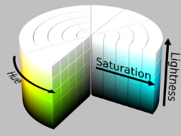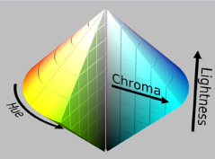

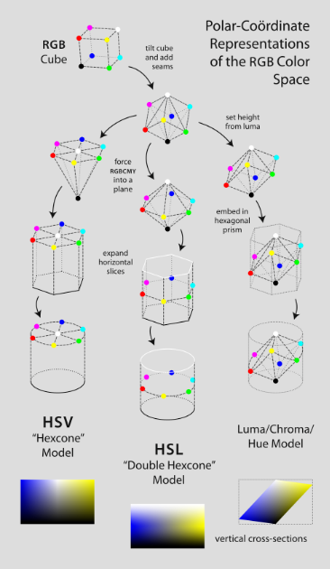

**RGB to HSL Conversion:**

1. Cmax = max(R, G, B), Cmin = min(R, G, B), delta = Cmax - Cmin
2. L = (Cmax + Cmin) / 2
3. S = delta / (1 - |2L - 1|) if delta ≠ 0, else 0
4. H is determined by comparing which of R, G, or B is maximum

**Usage and Limitations:**

* Widely used in image editing tools for its intuitive nature
* Limitation: not perceptually uniform (equal changes don’t equal perceived color shifts)
* Better perceptual models like CIELAB are more accurate but complex

**Difference Between HSV and HSL:**

|  |  |  |
| --- | --- | --- |
| **Aspect** | **HSV (Hue, Saturation, Value)** | **HSL (Hue, Saturation, Lightness)** |
| **Brightness axis** | Measures **brightness (value)** from black (0) to full color (1) | Measures **lightness** from black (0), through pure color (0.5), to white (1) |
| **Full saturation level** | Full saturation colors are always at **V=1** (top of cone) | Full saturation colors are at **L=0.5** (middle of bicone) |
| **Saturation meaning** | Measures how much **black is mixed** with the color | Measures how much **gray is mixed** with the color |
| **Model shape** | **Hexcone (cone)** | **Bi-hexcone (double cone or diamond shape)** |
| **White mixing behavior** | Adding white reduces **value but keeps saturation constant** | Adding white reduces **saturation** |

**3. YIQ COLOR SPACE :**

**Definition and Role in NTSC:**

YIQ is a color space used in the NTSC analog TV system, mainly in North America and Japan. It separates an image into:

* **Y (Luma):** Brightness (grayscale image)
* **I (In-phase):** Orange-blue chroma
* **Q (Quadrature):** Purple-green chroma

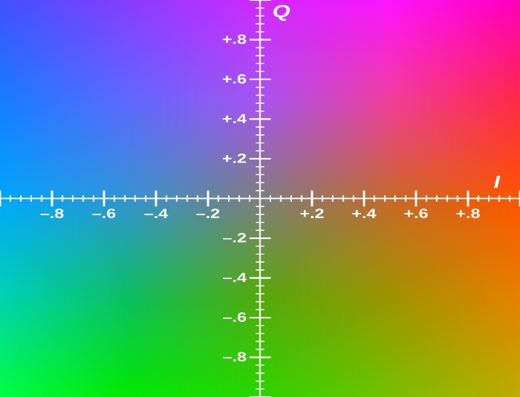

**Bandwidth Efficiency:**

* Human vision is more sensitive to orange-blue, so the I channel gets higher bandwidth
* I: 1.3 MHz, Q: 0.4 MHz

**Conversion:**

* Y = 0.299R + 0.587G + 0.114B
* I = 0.596R - 0.275G - 0.321B
* Q = 0.212R - 0.523G + 0.311B

**RGB Image Conversion to YIQ :**

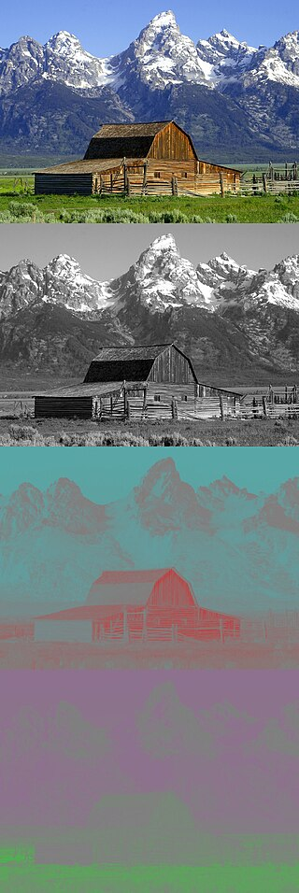

**Relation to YUV:**

YIQ is a rotation of YUV in the chrominance plane. Both share the same Y (luma) axis.

**Practical Use:**

YIQ ensured backward compatibility with B/W TVs. It is now rarely used but was implemented in high-end color TVs for better fidelity.

**COMPARATIVE SUMMARY**

|  |  |  |  |
| --- | --- | --- | --- |
| **Feature** | **YPbPr** | **HSL** | **YIQ** |
| Type | Analog video | Perceptual model | Analog TV |
| Luma Component | Y' | L (lightness) | Y |
| Chrominance | Pb, Pr | H, S | I, Q |
| Usage | Video electronics | Image editing | NTSC broadcasting |
| Perceptual Uniformity | No | Partially | Low |

**CONCLUSION**

Color spaces are essential in computer vision to represent, process, and transmit images effectively. While RGB is the most well-known, alternatives like YPbPr, HSL/HSV, and YIQ serve specific needs: efficient transmission, perceptual adjustments, and human vision alignment. A good understanding of these models allows developers to choose the best one for each task, improving both technical performance and visual quality.